|  |  |
| --- | --- |
| Project ID:  PNT2022TMID23211 | SOLUTION ARCHITECTURE |

**IOT BASED SMART CROP PROTECTION SYSTEM FOR AGRICULTURE**

The proposed solution is to protect the crop from animals and birds using a PIR sensor and sounds. Further to protect the crops from surrounding environments.

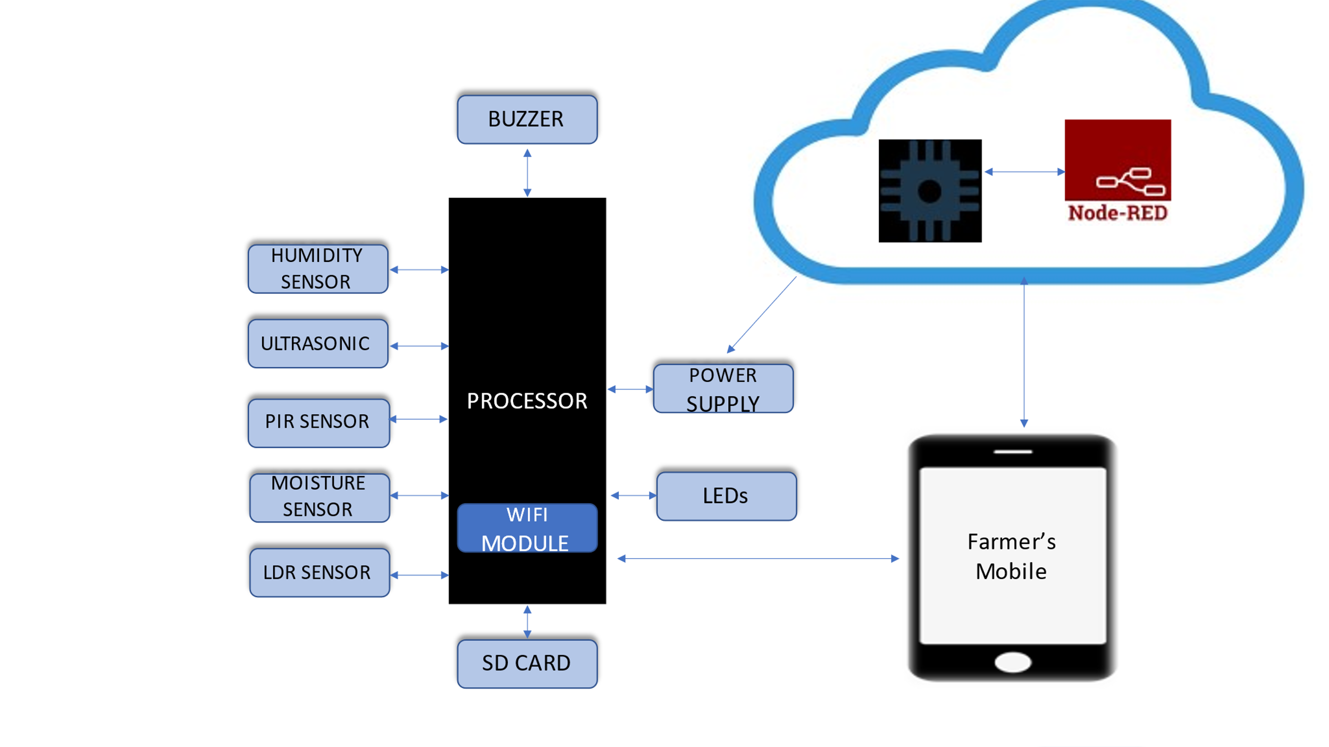

PROCESSOR AND SD CARD:

The Processor devours 700mA or 3W or power. Any decent smartphone mount will do the exertion of powering the Pi. In the processor onboard storage is unavailable. The functioning physique is loaded on an SD card entrenched in the processor's SD card slot. The functioning interpretation may want to additionally be loaded with the usage of a card reader on any computer.

SENSORS:

The PIR Sensor, Ultrasonic sensor, Soil moisture sensor and DHT 11 Humidity & Temperature Sensor

The **PIR Sensor** Swap Can Sense the Infrared Rays launched by humans as well as the Animals’ Physique Movement inside the Detection Space (14 Meters) and begin the Load - Mild Automatically

**Ultrasonic Device Functioning**: HC-SR04 is a 4-pin entity, whose pin expressions are Vcc, Trigger, Echo, and Ground. This Ultrasonic Sensor is a much conscious device used in a number of functions the domicile computing distance or recognizing things are required. The instrument works underneath the uncertain capability structure i.e; Distance = Speed × time. The Ultrasonic source transfers an ultrasonic wave, this mark travels in the air and when it gains complained with the aid of specific cloth it obtains copied nearby to the system this copied wave is sensed via the Ultrasonic receiver module as available in the design Now, to analyze the distance the usage of the above methods, we had advanced know the Speed and time. Then we're using the Ultrasonic wave we advance the speed of the US wave in room surroundings.

The **Soil moisture sensor** previous to the soil is consuming water shortage, the phase output is on an extreme level, in any other case the output is on a low level. By intake, this system one can certainly marine the blossoming plant, in some further sides any unlike plant life needful reaction irrigating performance. The aspects are sensitivity adaptable. It has a persistent bolt gap suitable set up . A threshold degree can be shaped.

The **LDR system** is preferred for automatic light control in agricultural fields.

The **Cloud setup** is used for collecting all the data from the sensors and updating the information on farmers’ mobile phones. It is also used to alert the farmers when there is an entry of animals or other unknown persons/strangers.